Research on Influencing Factors of Information Dissemination of
WeChat Public Accounts Based on FSIPS Two-stage Model
(Full Paper)
Bo Yang*, Renmin University of China, Beijing, China, yangbo_ruc@126.com
Xinrui Zhang, Renmin University of China, Beijing, China, 18146558586@163.com
Rong Zhang, Renmin University of China, Beijing, China, rongzhang_ruc@qq.com
Lilong Zhang, Renmin University of China, Beijing, China, zhanglilong0119@163.com
Ziyi Liang, Renmin University of China, Beijing, China, 583709715@qq.com
Lingling Wang, Beijing Institute of Technology, Beijing, China, 9150305@qq.com

ABSTRACT
The popularity and application of social media have a profound impact on user information dissemination in the Internet era. In China, WeChat's operation will face greater challenges as the number of Official Accounts climbs. This study focuses on the key factors of information dissemination effect in the two stage of "Sympathy under Feedback- Identify" and "Participate- Share& Spread" through constructing FSIPS two stage model, and analyzes the influencing factors of reading rate, comment rate and share rate from two dimensions in order to improve the distribution rate and information transmission for public operators.

Keywords: FSIPS Two-Stage Model, WeChat Official Accounts, Information Dissemination.
____________________
*Corresponding author

INTRODUCTION
In 2011, Tencent officially released WeChat, a new generation of communication social service software based on mobile Internet. As of the end of 2018, WeChat's daily login users have reached 1.025 billion. In July 2012, WeChat officially launched the Official Accounts function, linking users with information and services in the form of subscription number, enterprise number and service number, and became an important function layout of WeChat in the new media field. As of the first quarter of 2019, the number of WeChat Official Accounts that kept the publication reached 1.756 million.

However, with the increase in the number of WeChat Official Accounts, the operation and management of the WeChat Official
Accounts is facing greater challenges. According to Penguin Intelligence's “2017 WeChat User & Ecology Research Report” released in April 2017, the new challenge of WeChat Official Accounts operation is the difficulty of traffic acquisition, the low viscosity of followers, the increase of homogenization content and the reading volume is slower than that of its fans. In 2016, the number of fans of the Official Accounts was mostly below 100,000, and the number of heavyweight public numbers reaching a million fans was only 1.8%. The improvement of content distribution conversion rate and information transmission efficiency has become the top priority for many WeChat Official Accounts to develop into heavyweight accounts.

For the information dissemination research of WeChat Official Accounts, most scholars use observation method and questionnaire survey method. At present, the WeChat Official Accounts has gradually changed from single content distribution to commercialization and specialization mode, and a large number of third party operators have come into being. These third party operators record daily users' concerns and articles' push data for WeChat Official Accounts. Centralized storage management of backstage data provides reliable data resources for academic research and analysis of information dissemination mode and user behavior. The systematic research in the academic circles will also lay a solid theoretical foundation for the operators of small and medium-sized Official Accounts to find out key operational indicators, enhance the activity and retention rate of old customers, and stimulate the growth of new users' attention.

Based on the user behavior model of SIPS social media and combined with the information transmission path of WeChat Official Accounts, this study divided the spread process into two stages, namely, "Sympathy under Feedback- Identify" and "Partition-Share & Spread", so as to establish the FSIPS model for the social media of WeChat Official Accounts. Based on the actual operational data of nearly 20 public numbers provided by Beijing Sootoo Company from September 1, 2018 to November 30, 2018, the appropriate operational data indicators are selected to represent the influencing factors and effects of the spread, through the data preprocessing, TFIDF text classification model, negative binomial regression model and other technical means to complete the analysis of the factors affecting the two-stage information transmission of WeChat Official Accounts, and finally identify the key influencing factors of information dissemination.

LITERATURE REVIEW
At home and abroad, the research on social network information dissemination is mainly based on the theory of information dissemination diffusion and the theory of knowledge dissemination and sharing. Lasswell (1948) first proposed the five elements of information communication, now known as the Lasswell 5W model, which successively corresponds to the five elements of people, content, channel, receiver and communication channel. Williamson (2011) proposed that communication influence is communication ability and its influence. Ni Yannian (2002) divided the knowledge communication into seven parts: the initiative, the receiver, the information, the specific behavior, the environment, the purpose and the final effect. Li Gang et al. (2013) elaborated the influence of network structure, network connection and social capital on knowledge sharing behavior, and summarized the guarantee and incentive mechanism of knowledge sharing. Using the theory of system dynamics and simulation experiments, Fumito comprehensively studied the factors affecting the five stages of information diffusion, and put forward relevant supporting suggestions in combination with enterprise practice.

Foreign researches on the mechanism of information dissemination and diffusion in new media social platforms mainly focus on Twitter and Facebook. Based on Twitter data, foreign scholars have provided valuable research conclusions for finding the most influential users in social platforms. The research found that the forwarding and sharing performance of star users' tweets is not necessarily the best. On the other hand, it verified that the influence of social platform users is not only related to the number of fans. Webberley et al. (2011) studied the main influencing factors of the depth and breadth of Twitter information dissemination. Yang et al. (2010) found that the content of information and the mentioning rate of related users are the key factors affecting information dissemination. In the Facebook platform, content vividness will have an impact on likes and comments. Facebook users are active for a period of time, which has a certain impact on the effect of information dissemination.

DATA PTOCESSING AND VARIABLE SETTING
This study selected 21 WeChat Official Accounts operated and managed by Beijing Sootoo company, involving three Official Accounts of life, entertainment and information, including 8 Official Accounts of life, 4 Official Accounts of entertainment and 9 Official Accounts of information. Data of 3,286 articles from September 1, 2018 to November 30, 2018 were collected, and
2,969 articles were retained after outliers were removed, re-nulling and pre-screening.

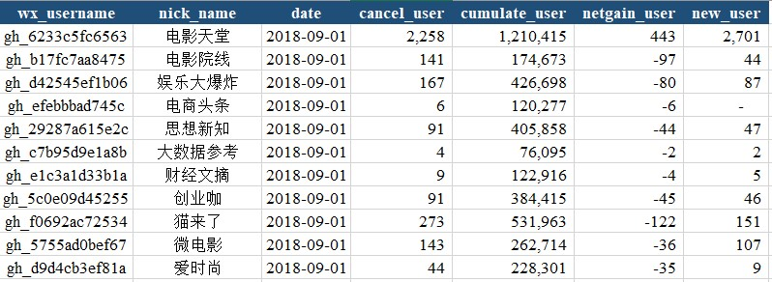
Figure 1: Changes in the Subscribed Users Number of the WeChat Official Accounts

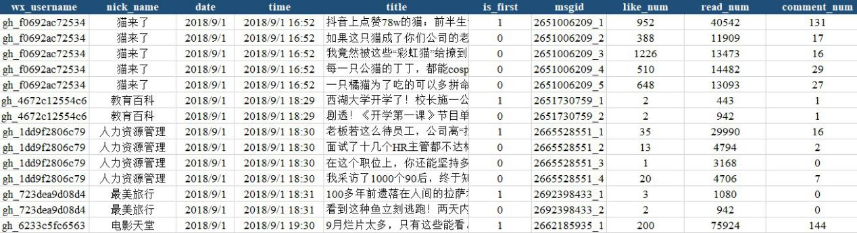
Figure 2: Article Data Sample

The Jieba word segmentation algorithm uses the prefix dictionary in the data structure to scan and classify Chinese characters, with high efficiency and precision. The Jieba algorithm has three modes: search engine mode, precise mode, and full mode. In order to analyze and segment the text as accurately as possible, the study selected the precise mode. We can quickly calculate the TF-IDF weights of different word segments by using the Count Vectorizer and TF-IDF Transformer classes in the Scikit-Learn package，thereby extracting the article content keywords whose TF-IDF weights are located in the top ten, and outputting the results to the specified Excel file as required. The specific code and calculation results are shown in the figure below.

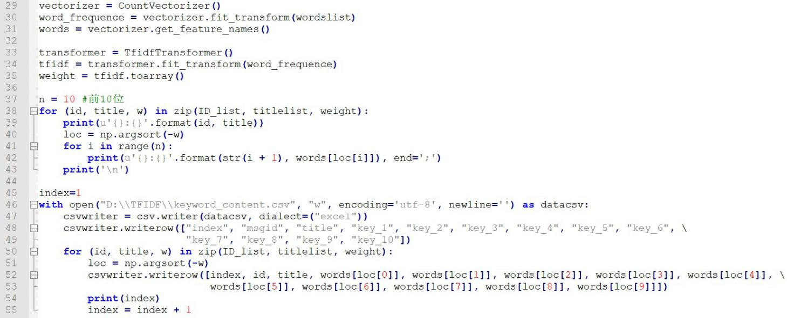
Figure 3: Calculation Process of TF-IDF Algorithm

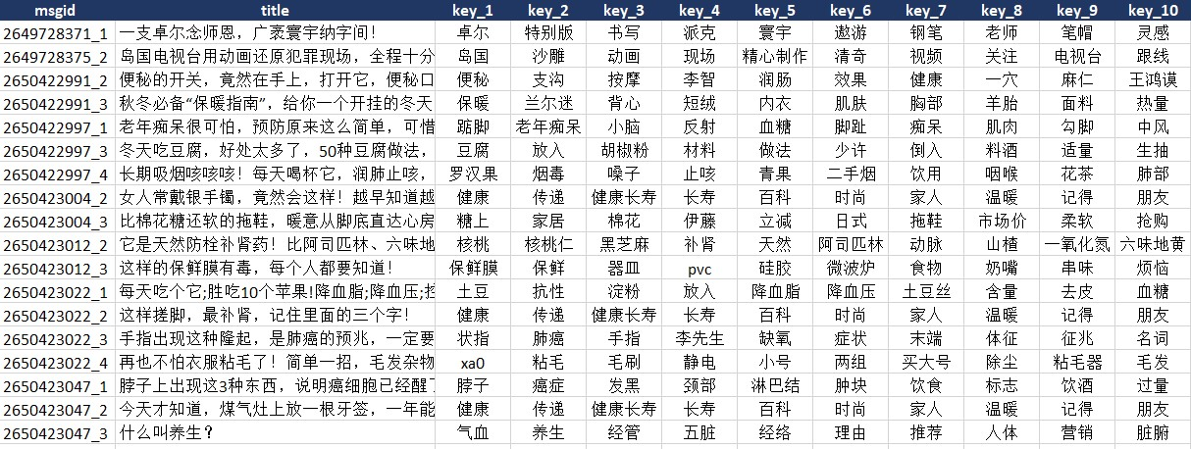
Figure 4: Samples of Keyword Extraction Result

This study comprehensively considered the non-linear and multi-point information transmission scene and characteristics of Official Accounts as a new media social platform, and modified the existing SIPS model to form a two-stage FSIPS model (as shown in figure 5). The dissemination of articles on the Official Accounts is characterized as two stages of "Sympathy under
Feedback- Identify" and "Partition-Share & Spread".

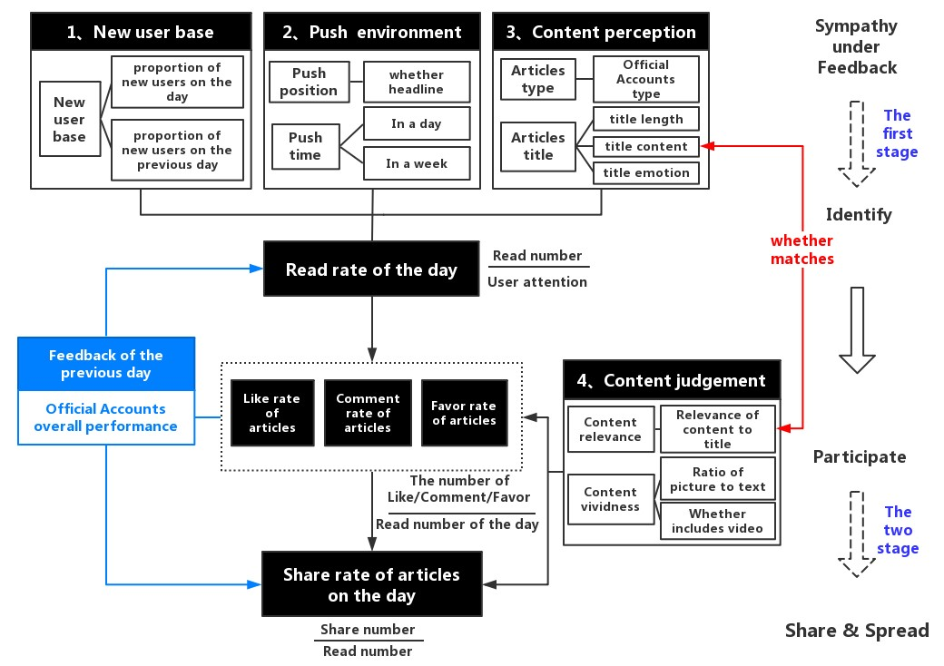
Figure 5 : Basic Schematic Diagram of Two-stage FSIPS Model

The first stage research model takes the click-reading rate of the article as the research object, Number of subscribed users of the day as the exposure variable, and we select the potential influencing factors as the independent variables in the four dimensions of new users, push environment, external content perception and feedback influence, set the reading number as a dependent variable, and further focus on the behavior conversion mechanism of WeChat users "focus-click-read".

In the second stage, we take the views of articles as the exposure variable, the favor rate, comment rate and share rate of article, as well as the internal characteristics of content (content vividness, content relevance) as independent variables, the number of article share as dependent variable, to test their impact on the users "Shared diffusion" stage.

The definitions of dependent and exposed variables are shown in table 1, and the independent variables are shown in table 2.

Table 1: Dependent and Exposed Variable Definitions
Variable definitions | Stage | Independent variables | Variables identify
Dependent variable | The first stage  The two stage | Read number of the day Share number of the day | read_num(i,j,t) share_num(i,j,t)
Exposure variable | The first stage | Official Accounts’cumulate user of the day | cumulate_user  (i, t)
 | The two stage | Official Accounts’read number of the day | read_num(i,j,t)

Table 2: Independent Variable Definition
Stage | Dimension | Independent variables | Variables identify
The first stage | New user base | The proportion of new users on the day | ratio_newuser (i, t)
 |  | The proportion of new users on the previous day | ratio_newuser_t1(i, t-1)
 | Push environment | Push time whether weekend | is_weekend (i, j, t)
 |  | Whether lunch break | is_noonbreak (i, j, t)
 |  | Whether time from work | is_quitting (i, j, t)
 |  | Whether before bedtime | is_bedtime (i, j, t)
 |  | Push position whether headline | is_first (i, j, t)
 | Content perception | Official Accounts type | account_type (i)
 |  | Whether title length not more than 15 words | is_notmorethan15 (i, j, t)
 |  | Whether title contains emotional punctuation | is_emotional (i, j, t)
 | Feedback influence | Comment rate of the previous day | ratio_comment_t1 (i, t-1)
 |  | Like rate of the previous day | ratio_like_t1 (i, t-1)
 |  | Favor rate of the previous day | ratio_favor_t1 (i, t-1)
 |  | Share rate of the previous day | ratio_share_t1 (i, t-1)
The two stage | Action  participation | Comment rate of the day | ratio_comment (i, j, t)
 |  | Like rate of the day | ratio_like (i, j, t)
 |  | Favor rate of the day | ratio_favor (i, j, t)
 | Content judgement | Official Accounts type | account_type (i)
 |  | Picture text ratio | conlen_img (i, j, t)
 |  | Whether contains video | is_includevideo (i, j, t)
 |  | Content middle matches title | middle_relevance (i, j, t)
 |  | Content high matches title | high_ relevance (i, j, t)

MODEL CONSTRCTING

“Sympathy under Feedback- Identify” Model
Firstly, this chapter uses the negative binomial regression model to describe the distribution of the number of times that WeChat users click to read an article per unit time. Taking the reading amount of the article in the jth article published by WeChat Official Account i on the t-day as an example, the reading amount in the day is recorded as read_num (i, j, t). The observation time is divided into infinite average segments, which approximately gives each concerned user a period of time to decide whether to read or not. The click-and-read behavior of concerned users in different periods of time is mutually independent. Then the average reading amount per unit time is read_num (i, j, t) / cumulate_user (i, t), that is, the reading rate of articles is read_ratio (i, j, t), which obeys the negative binomial distribution. The main factors affecting the click reading rate can be studied by establishing a negative binomial regression equation.

We introduce the independent and dependent variables in the first stage of FSIPS "Sympathy under Feedback-Identify" into the negative binomial regression equation, and construct the research model as follows (1):
(1)

By shifting the items of the total number of subscribed users cumulate_user (i, t) on the day, the following formula can be obtained (2):

(2)

Next, we will take life, entertainment and information as the research objects, and establish negative binomial regression equation, as follows (3), in order to identify the main factors affecting the click-through reading rate of different types of articles (k = 1, 2, 3), and to sum up and compare the significant factors according to the actual situation.
(3)

“Partition-Share & Spread”Model
With the help of negative binomial regression model to describe WeChat users after clicking and reading an article, this paper continues to study the distribution of the occurrence of "Share & Spread" event. Take the sharing amount of the article “j” published by Wechat Official Accounts “I” on the day “t” as an example, the sharing amount is recorded as share_num (i, j, t). The observation time is divided into infinite averages, approximately giving each user who has read this article a period of time to choose whether to continue to share this article with other users. The forwarding and sharing behavior of users who have read in different periods is independent of each other. Then the average number of reads per unit time is share_num(i,j,t)/read_user(i,j,t). That is to say, the forwarding and sharing rate share_ratio(i,j,t) of articles obeys the negative binomial distribution. The main factors affecting forwarding and sharing rate can be studied by establishing a negative binomial regression equation.

The independent and dependent variables in the second stage of FSIPS "Partition-Share & Spread" are introduced into the negative binomial regression equation. The research model is as follows (4):
(4)

The reading number read_num (i, j, t) of the articles on the same day is taken as the exposure variable, and the following formula (5) can be obtained by shifting the items.

(5)

Similar to the research process of the first stage, the next three kinds of articles about life, entertainment and information are respectively established negative binomial regression equation as follows (6), to identify the main factors affecting the forwarding and sharing rate of different types of articles (k = 1, 2, 3), and to compare and analyze the regression equation of different types.

(6)

RESULT ANALYSIS
Through STATA15 to complete two stages of negative binomial regression analysis, we summarized and compared the main influencing factors of the dissemination effect of three types of WeChat Official Accounts articles.

Empirical Analysis of the First Stage
Overall, 2969 descriptive statistics of 21 Wechat Official Accounts in three months are shown in Table 3. Among them, 1169 are life, 648 are entertainment and 1152 are information.

The average number of subscribed users to Official Accounts is 551,000, the maximum number of subscribed users is 1.25 million, and the minimum subscribed users is 29,670. The proportion of new users added in one day can reach 18.8%. The average number of reading a single article is 102,000, with a maximum of 218,000 and a minimum of 8,237. 32.3% of the articles are in the headlines. 26% of articles were pushed on weekends; 41.3% of articles were pushed on weekends (17:30-20:00), while 20.3% were pushed on bedtime (21:30-23:30), 27% of the titles of public documents are less than 15 words.

For the feedback effect of Official Accounts, the average values of comment rate, Like rate, favor rate and share rate on the previous day were between 11.5% and 15.5%.

Table 3 : Descriptive Statistical Results of the Overall Data in the overall data
Variable | Obs | Mean | Std.Dev. | Min | Max
account_type | 2969 | 1.994 | .884 | 1 | 3
is_includevideo | 2969 | .135 | .342 | 0 | 1
ratio_commment | 2969 | .002 | .003 | 0 | .079
ratio_like | 2969 | .012 | .015 | 0 | .127
ratio_favor | 2969 | .008 | .011 | 0 | .176
read_num | 2969 | 8237.715 | 10171.36 | 19 | 218000
share_num | 2969 | 265.551 | 621.426 | 0 | 16091
conlen_img | 2969 | 191.719 | 278.85 | 0 | 5652.5
middle_relevance | 2969 | .089 | .285 | 0 | 1
high_ relevance | 2969 | .378 | .485 | 0 | 1

The negative binomial regression results of the overall data show that the result of "LR test of alpha = 0" is significant, so we should choose the negative binomial regression model when the overall data in the first stage is over-discrete.

According to the IRR value (IRR = exp (Coef.) in Table 4, we can see that besides the type of Wechat Official Accounts, if the article title contains emotional symbols, the push position is the headline, and the overall comment rate and the comment rate of the previous day passed the significance test of 99% confidence, the read rate of the articles will be positively affected; If push time is at bedtime, the title of the article does not exceed 15 words, the overall favor rate of Wechat Official Accounts the day before passed the significance test of 95% confidence, the read rate of the articles will be positively affected; At the 90% confidence level, push time (17:30-20:00) would have a positive impact on articles in the off-duty time (17:30-20:00).

Table 4 : Negative Binomial Regression Results of Overall Data on the First Stage
read_num | IRR | St.Err. | t-value | p-value | [95% Conf |  | Interval] | Sig
1b.account_type | 1.000 | . | . | . | . |  | .
2.account_type | 1.303 | 0.056 | 6.11 | 0.000 | 1.197 |  | 1.418 | ***
3.account_type | 0.567 | 0.020 | -16.33 | 0.000 | 0.530 |  | 0.607 | ***
ratio_newuser | 0.724 | 1.563 | -0.15 | 0.881 | 0.011 |  | 49.735
ratio_newuser_t1 | 0.297 | 0.543 | -0.66 | 0.507 | 0.008 |  | 10.724
is_weekend | 1.025 | 0.028 | 0.91 | 0.364 | 0.972 |  | 1.080
is_noonbreak | 1.051 | 0.124 | 0.42 | 0.671 | 0.835 |  | 1.324
is_quitting | 1.056 | 0.035 | 1.66 | 0.098 | 0.990 |  | 1.126 | *
is_bedtime | 0.949 | 0.036 | -6.39 | 0.035 | 0.881 |  | 1.022 | **
is_emotional | 0.874 | 0.021 | -5.55 | 0.000 | 0.833 |  | 0.916 | ***
is_first | 3.048 | 0.077 | 43.94 | 0.000 | 2.901 |  | 3.204 | ***
is_notmorethan15 | 0.941 | 0.025 | -2.27 | 0.023 | 0.893 |  | 0.992 | **
ratio_comment_t1 | 1.52E-09 | 3.89E-09 | -7.94 | 0.000 | 1.01E-11 |  | 2.29E-07 | ***
ratio_like_t1 | 4.14E+1  0 | 6.14E+10 | 16.50 | 0.000 | 2.27E+09 |  | 7.56E+11 | ***
ratio_favor_t1 | 0.013 | 0.024 | -2.32 | 0.020 | 0.000 |  | 0.507 | **
ratio_share_t1 | 0.840 | 0.492 | -0.30 | 0.766 | 0.267 |  | 2.646
Constant | 0.009 | 0.000 | -97.31 | 0.000 | 0.008 |  | 0.010 | ***
lnalpha | -0.903 | 0.024 | .b | .b | -0.951 |  | -0.855
Mean dependent var |  | 8237.715 | SD dependent var |  |  | 10171.365
Pseudo r-squared |  | 0.043 | Number of obs |  |  | 2969.000
Chi-square |  | 2477.398 | Prob > chi2 |  |  | 0.000
Akaike crit. (AIC) 55496.239 Bayesian crit. (BIC)  LR test of alpha=0: chibar2(01) = 7.9e+06 Prob >= chibar2 = 0.000 |  |  |  |  |  | 55598.170
*** p<0.01, ** p<0.05, * p<0.1

The descriptive statistical results of the life Official Accounts are shown in table 5 below. Of the 1169 background operating data, 34.6% of the articles were in the headlines. 26% of articles were pushed on weekends; 13.7% were pushed at bedtime (21:30-23:30), and 16.3% were pushed at off-duty time (17:30-20:00). 20.2% of the titles of the articles were controlled within 15 words.

For the feedback effect of Wechat Official Accounts information dissemination, the average comment rate, Like rate, favor rate and share rate of articles on the previous day were between 10.5% and 13.0%.

The negative binomial regression results of life Official Accounts are also too discrete, so the negative binomial regression model is chosen.

The article title contains emotional symbols, the push position is the headline, and the overall comment rate and Like rate of Wechat Official Accounts the day before still passed the significance test of 99% confidence. At the same time, push time for bedtime also has a very significant positive impact on reading rate.

Table 5 : Descriptive Statistics of the Life Official Accounts in the First Stage
Variable | Obs | Mean | Std.Dev. | Min | Max
cumulate_user | 1169 | 410000 | 212000 | 89333 | 651000
ratio_newuser | 1169 | 0 | .001 | 0 | .009
ratio_newuser_t1 | 1169 | 0 | .001 | 0 | .009
is_weekend | 1169 | .262 | .44 | 0 | 1
is_noonbreak | 1169 | .011 | .105 | 0 | 1
is_quitting | 1169 | .163 | .369 | 0 | 1
is_bedtime | 1169 | .137 | .344 | 0 | 1
is_emotional | 1169 | .577 | .494 | 0 | 1
is_first | 1169 | .346 | .476 | 0 | 1
is_notmorethan15 | 1169 | .202 | .402 | 0 | 1
ratio_comment_t1 | 1169 | .09 | .283 | 0 | 1
ratio_like_t1 | 1169 | .106 | .279 | 0 | 1
ratio_favor_t1 | 1169 | .095 | .281 | 0 | 1
ratio_share_t1 | 1169 | .127 | .274 | .001 | 1
read_num | 1169 | 8854.151 | 9665.223 | 112 | 122000

Unlike the regression results of the overall data, the title not exceeding 15 words and overall favor rate of Wechat Official Accounts no longer had a significant positive impact on the reading rate of the push articles. At 90% confidence level, the proportion of new users on the same day will positively affect the reading rate of push articles.

Table 6 : Negative Binomial Regression Results of Life Official Accounts in the First Stage
read_num | IRR | St.Err. | t-value | p-value | [95% Conf |  | Interval] | Sig
ratio_newuser | 4.950E+29 | 1.940e+31 | 1.75 | 0.081 | 0.000 |  | 1.080E+63 | *
ratio_newuser_t1 | 6.730E+17 | 2.310e+19 | 1.20 | 0.231 | 0.000 |  | 9.360E+46
is_weekend | 1.042 | 0.041 | 1.03 | 0.303 | 0.964 |  | 1.126
is_noonbreak | 1.046 | 0.176 | 0.27 | 0.788 | 0.752 |  | 1.456
is_quitting | 0.934 | 0.046 | -1.37 | 0.171 | 0.848 |  | 1.030
is_bedtime | 0.651 | 0.035 | -7.97 | 0.000 | 0.586 |  | 0.724 | ***
is_emotional | 0.901 | 0.032 | -2.92 | 0.003 | 0.841 |  | 0.966 | ***
is_first | 2.401 | 0.090 | 23.33 | 0.000 | 2.231 |  | 2.584 | ***
is_notmorethan15 | 0.993 | 0.043 | -0.16 | 0.874 | 0.912 |  | 1.082
ratio_comment_t1 | 2.71E-10 | 8.83E-10 | -6.76 | 0 | 4.57E-13 |  | 1.61E-07 | ***
ratio_like_t1 | 2.27E+10 | 3.75E+10 | 14.47 | 0 | 8.99E+08 |  | 5.75E+11 | ***
ratio_favor_t1 | 0.288 | 0.759 | -0.47 | 0.637 | 0.002 |  | 50.157
ratio_share_t1 | 0.613 | 0.439 | -0.69 | 0.494 | 0.151 |  | 2.492
Constant | 0.009 | 0.001 | -80.50 | 0.000 | 0.008 |  | 0.011 | ***
lnalpha | -1.056 | 0.039 | .b | .b | -1.133 |  | -0.979
Mean dependent var |  | 8854.151 | SD dependent var |  |  | 9665.223
Pseudo r-squared |  | 0.034 | Number of obs |  |  | 1169.000
Chi-square |  | 773.254 | Prob > chi2 |  |  | 0.000
Akaike crit. (AIC) 21997.120 Bayesian crit. (BIC)  LR test of alpha=0: chibar2(01) = 2.4e+06 Prob >= chibar2 = 0.000 |  |  |  |  |  | 22073.079

Similarly, in 648 background operating data of entertainment Official Accounts, for the feedback effect of Wechat Official Accounts information dissemination, the average comment rate, Like rate, favor rate and share rate on the previous day were about 21%. At 99% confidence level, the title control was within 15 words and the push position was the headline. At the same time, at 95% confidence level, push time at bedtime (21:30-23:30) positively affects the reading rate of articles; at 90% confidence level, the proportion of new users at the previous day and articles pushed over the weekend has a significant positive impact on the reading rate. Controlling the number of characters to less than 15 words no longer has a significant positive impact on the reading rate of articles.

There are 1152 articles of information Official Accounts. The average comment rate, Like rate, favor rate and share rate of Wechat Official Accounts on the previous day are between 9% and 14%. For information Official Accounts, the proportion of new users added to the Official Account on that day, the position of push is the headline, the time of push is the bedtime period, and the number of titles of articles does not exceed 15 words, all of these conditions passed the significance test of 99% confidence. Comparatively, among the factors of feedback effect of the previous day's Official Account information dissemination, only the overall Like rate will have a positive impact on the reading rate, while the overall comment rate, favor rate and share rate have not passed the significant test.

Empirical Analysis of the Second Stage
According to the statistical results of the second stage of 2969 push articles from 21 Wechat Official Accounts (as shown in Table 7 below), the average number of share of single push articles is 266, up to 161,000.

About the content vividness, 13.5% of the articles contain multimedia information such as video; the average ratio of text to picture is 192, that is to say, an average of 192 text texts will contain 1 picture.

About the content relevance, 37.8% of the text is highly correlated with its title, and 8.9% of the text is moderately correlated with its title.

From the pre-effect of Official Accounts information dissemination, the average comment rate of Official Accounts push articles is the lowest, only 0.2%, followed by the favor rate, which is 0.8%, while the average Like rate is relatively high, which is 1.2%.

Table 7: Descriptive Statistics of Overall Data in the Second Stage
Variable | Obs | Mean | Std.Dev. | Min | Max
account_type | 2969 | 1.994 | .884 | 1 | 3
is_includevideo | 2969 | .135 | .342 | 0 | 1
ratio_commment | 2969 | .002 | .003 | 0 | .079
ratio_like | 2969 | .012 | .015 | 0 | .127
ratio_favor | 2969 | .008 | .011 | 0 | .176
read_num | 2969 | 8237.715 | 10171.36 | 19 | 218000
share_num | 2969 | 265.551 | 621.426 | 0 | 16091
conlen_img | 2969 | 191.719 | 278.85 | 0 | 5652.5
middle_relevance | 2969 | .089 | .285 | 0 | 1
high_ relevance | 2969 | .378 | .485 | 0 | 1

In the second stage, "LR test of alpha = 0" is still significant, so the overall data in the second stage is still excessively discrete and should continue to use the negative binomial regression model.

According to the IRR value (IRR = exp (Coef.) ) of Table 8, we can see that the independent variable of Official Account type passed the significance test with 99% confidence, which had a significant impact on the share rate of articles. Under the same conditions, the information Official Accounts (IRR = 0.050) had the best sharing effect, followed by the entertainment Official Accounts (IRR = 0.018).

From the dimension of the content vividness, at 99% confidence level, content containing video and multimedia information will have a significant positive impact on the share rate, while the ratio of text to picture has not passed the significance test.

As for the dimension of the content relevance, the high correlation between content and its title will positively affect the share rate at 99% confidence level, while the moderate correlation between content and its title will positively affect the share rate at 90% confidence level.

In the pre-effect dimension of information dissemination, both the Like rate and the favor rate passed the significance test of 99% confidence, which had a significant positive impact on the share rate, while the related impact of comment rate was not significant. However, by comparing the IRR values of the two independent variables, the positive unit effect of the favor rate is much higher than the positive unit effect of the favor rate.

Table 8: Negative Binomial Regression Results of Life Official Account in the Second Stage
share_num | IRR | St.Err. | t-value | p-value | [95% Conf | Interval] | Sig
1b.account_type | 1.000 | . | . | . | . | .
2.account_type | 0.394 | 0.018 | -20.59 | 0.000 | 0.361 | 0.431 | ***
3.account_type | 1.254 | 0.050 | 5.70 | 0.000 | 1.160 | 1.355 | ***
is_includevideo | 1.564 | 0.073 | 9.64 | 0.000 | 1.428 | 1.713 | ***
ratio_comment | 2079.668 | 14306.136 | 1.11 | 0.267 | 0.003 | 1490000000
ratio_like | 0.000 | 0.000 | -7.50 | 0.000 | 0.000 | 0.001 | ***
ratio_favor | 1.160e+20 | 2.440e+20 | 21.95 | 0.000 | 1.870e+18 | 7.170e+21 | ***
conlen_img | 1.000 | 0.000 | 1.31 | 0.191 | 1.000 | 1.000
middle_relevance | 0.910 | 0.052 | -1.66 | 0.097 | 0.814 | 1.017 | *
high_relevance | 1.122 | 0.038 | 3.43 | 0.001 | 1.050 | 1.198 | ***
Constant | 0.021 | 0.001 | -83.98 | 0.000 | 0.019 | 0.023 | ***
lnalpha | -0.363 | 0.024 | .b | .b | -0.411 | -0.315
Mean dependent var |  | 265.551 | SD dependent var |  |  | 621.426
Pseudo r-squared |  | 0.046 | Number of obs |  |  | 2969.000
Chi-square |  | 1626.156 | Prob > chi2 |  |  | 0.000
Akaike crit. (AIC) 33940.189 Bayesian crit. (BIC)  LR test of alpha=0: chibar2(01) = 6.0e+05 Prob >= chibar2 = 0.000 |  |  |  |  |  | 34006.144
*** p<0.01, ** p<0.05, * p<0.1

The descriptive statistical results of 1169 articles from 8 life Wechat Official Accounts in the second stage can be found in Table 9. The average number of individual share was 317, with a maximum of 106,000. Among them, 17.1% of the articles contain video information; the average ratio of text to picture is 100. From the correlation dimension of the article content, 34% of the articles are highly related to their titles, while 9.3% of the articles are moderately related to their titles. The average comment rate is still the lowest, only 0.2%; the second is the average favor rate, which is 0.8%; and the average Like rate is the highest, which is 2%.

The negative binomial regression results of the Life Official Accounts in the second stage can be seen in Table 10 below.

From the dimension of the content vividness, at the level of 99% confidence, the content of articles including video multimedia information and text-to-picture ratio will have a significant positive impact on the article share rate.

Table 9: Negative Binomial Regression Results of Life Official Account in the Second Stage
Variable | Obs | Mean | Std.Dev. | Min | Max
is_includevideo | 1169 | .171 | .377 | 0 | 1
ratio_comment | 1169 | .002 | .002 | 0 | .035
ratio_like | 1169 | .02 | .021 | 0 | .127
ratio_favor | 1169 | .008 | .011 | 0 | .079
read_num | 1169 | 8854.151 | 9665.223 | 112 | 122000
share_num | 1169 | 316.695 | 683.777 | 0 | 10611
middle_releavance | 1169 | .093 | .291 | 0 | 1
high_ releavance | 1169 | .34 | .474 | 0 | 1
conlen_img | 1169 | 100.113 | 213.936 | 0 | 5652.5

From the dimension of the content relevance, unlike the regression results of the overall data in the second stage, the two independent variables (high correlation, moderate correlation) of Life Official Accounts failed to pass the significance test.

About the pre-effect of Official Accounts information dissemination, besides the Like rate and favor rate of push articles passed the prominence test of 99% confidence, the comment rate also passed the prominence test. By comparing the IRR values of three independent variables, it was found that the positive unit effect of the favor rate was higher than that of the comment rate, which was much higher than that of the Like rate.

Table 10: Negative Binomial Regression Results of Life Official Account in the Second Stage
share_num | IRR | St.Err. | t-value | p-value | [95% Conf | Interval] | Sig
is_includevideo | 1.357 | 0.094 | 4.39 | 0.000 | 1.184 | 1.555 | ***
ratio_comment | 3.800e+16 | 4.980e+17 | 2.91 | 0.004 | 261000.000 | 5.510e+27 | ***
ratio_like | 0.000 | 0.000 | -6.72 | 0.000 | 0.000 | 0.001 | ***
ratio_favor | 2.200e+25 | 8.100e+25 | 15.84 | 0.000 | 1.610e+22 | 3.000e+28 | ***
conlen_img | 1.001 | 0.000 | 5.40 | 0.000 | 1.001 | 1.002 | ***
middle_relevance | 0.863 | 0.081 | -1.57 | 0.116 | 0.718 | 1.037
high_relevance | 1.081 | 0.064 | 1.33 | 0.183 | 0.964 | 1.213
Constant | 0.017 | 0.001 | -58.61 | 0.000 | 0.015 | 0.019 | ***
lnalpha | -0.253 | 0.038 | .b | .b | -0.328 | -0.178
Mean dependent var 316.695 SD dependent var 683.777
Pseudo r-squared 0.043 Number of obs 1169.000
Chi-square 621.665 Prob > chi2 0.000
Akaike crit. (AIC) 13690.566 Bayesian crit. (BIC) 13736.142

*** p<0.01, ** p<0.05, * p<0.1

Similarly, the average number of share from the individual articles of Entertainment Wechat Official Accounts is 116, with a maximum of 1154. The average Like rate, favor rate and comment rate ranged from 0.2% to 0.8%. The average Like rate was the highest, significantly higher than the favor rate and comment rate. According to the IRR value calculation results, at the 99% confidence level, the positive influence of article containing video multimedia information (IRR=2.018) is higher than that of the text-to-picture ratio (IRR=0.999); in the content relevance dimension, high correlation and moderate correlation will have a significant positive impact on the article share rate, high correlation (IRR = 1.264) articles have more positive unit influence than moderate correlation (IRR = 0.751). It is noteworthy that the positive unit influence of the Like rate(IRR = 1.830E + 25)
of Entertainment Official Accounts is significantly higher than that of the Life Official Accounts (IRR = 0.000). Among the three independent variables of the favor rate, the comment rate and the Like rate of Entertainment Official Accounts, the positive unit effect of the favor rate is higher than Like rate, and the Like rate is higher than the comment rate.

The average number of individual articles shared in Information Official Accounts is 298, with a maximum of 161,000. Among them, the average Like rate, favor rate and comment rate is between 0.1% and 1.2%, but the average favor rate is the highest, significantly higher than the Like rate and comment rate. At 99% confidence level, video multimedia information and text-to-picture ratio have a significant positive impact on the article share rate. Only one independent variable with high correlation passed the 90% significance test. At a certain level of confidence, the comment rate, favor rate and comment rate of push articles will have a positive impact on the share rate. The positive unit effect of comment rate is higher than the favor rate, which is far higher than the comment rate.

Comparison of Influencing Factors of Different Types of WeChat Official Accounts in Two Stages
Previous studies by scholars have found that the popularity of articles in Official Accounts is related to the theme to some extent, and the reading amount is also affected by the type of articles. We substitute the WeChat Official Accounts type into the negative binomial regression equation as the classification variable. The calculation results of STATA 15 show that, at the confidence level of 99%, the independent variable WeChat Official Accounts type will have a significant impact on the reading rate of articles pushed by the dependent variable. According to the IRR value, the positive influence of the three Official Accounts is: entertainment > life > information, that is, under the same conditions, the number of articles read by the entertainment public accounts will be higher than that of life accounts, and the number of articles read by the life public accounts will be higher than that of information accounts.

Table 11: The influence of WeChat Official Accounts type in the first stage
Read_num | IRR | St.Err. | T-value | P-value | Sig
1.account_type | 1
2.account_type | 1.303 | 0.056 | 6.11 | 0 | ***
3.account_type | 0.567 | 0.02 | -16.33 | 0 | ***

When the information dissemination enters the second stage, the order of positive influence of the three public accounts is changed into: information > life > entertainment . The difference between the two stages is reasonable, because the depth of user participation in the second stage is higher than that in the first stage. In the first stage, articles published by the entertainment Official Accounts can better meet WeChat users' demand for relaxation and entertainment. In the second stage, WeChat users are more inclined to consider the information value of articles on the Official Accounts. Therefore, the information Official Accounts plays the first role in promoting the effect of article sharing.

Table 12: The influence of WeChat Official Accounts type in the second stage
Read_num | IRR | St.Err. | T-value | P-value | Sig
1.account_type | 1
2.account_type | 0.394 | 0.018 | -20.59 | 0 | ***
3.account_type | 1.254 | 0.05 | 5.7 | 0 | ***

From the perspective of influencing factors, according to the following table, for "Sympathy under reverse-identify", independent variables in the following four dimensions all have a significant impact on the rate of article reading.

First is the new users dimension. For the purpose of obtaining effective information, the percentage of new users in the information (99% confidence level) and life (90% confidence level) will have a significant positive impact on the reading rate of articles.

Second is the push environment dimension. Firstly, time is an important factor influencing the information transmission. The push time can significantly improve the reading rate of articles before bed time. Secondly, push location has a significant positive impact on the number of reads, which has also been verified in our experiment.

Next is the external content perception dimension. As a typical external feature, the title length of the article on the Official Accounts affects the click rate to some extent. Also, whether the title contain emotional punctuation ("? "!" ) or not will significantly affect the life and information of the Official Accounts of the article reading rate.

Final is the feedback influence dimension. The overall comment rate of the WeChat Official Accounts on the previous day will significantly improve the reading rate of articles on the same day by the Official Accounts of life and entertainment, especially for entertainment (IRR is extremely high).

Table 13: Comparison of Significance Test Results of Independent Variables in the First Stage

Independent 1. Life 2. Entertainment 3. Information
variables IRR Sig IRR Sig IRR Sig
ratio_newuser | 4.95E+29 | * | 0.439 |  | 3.80E+279 | ***
ratio_newuser_t1 | 6.73E+17 |  | 0.098 | * | 8.50E-54
is_weekend | 1.042 |  | 0.924 | * | 1.068
is_noonbreak | 1.046 |  | 1.262 |  | 0.71
is_quitting | 0.934 |  | 1.092 |  | 0.946
is_bedtime | 0.651 | *** | 0.854 | ** | 1.179 | ***
is_emotional | 0.901 | *** | 0.966 |  | 0.848 | ***
is_first | 2.401 | *** | 2.376 | *** | 4.643 | ***
is_notmorethan15 | 0.993 |  | 0.862 | *** | 1.009
ratio_comment_t1 | 2.71E-10 | *** | 1.49E+13 | *** | 4.54E-07
ratio_like_t1 | 2.27E+10 | *** | 2.276 |  | 6613915 | *
ratio_favor_t1 | 0.288 |  | 0 | *** | 0.055
ratio_share_t1 | 0.613 |  | 0 | *** | 3.731

For "Partition-Share & Spread" , the second stage, there are independent variables in the two dimensions of internal content judgment (content relevance, content vividness) and the article dissemination effect in the previous stage (comment rate, favor rate and share rate) that will affect the article share rate.

From the perspective of content relevance of content judgment dimension, the positive influence of article sharing rate of entertainment Official Accounts has been verified, and the unit efficacy of highly correlated independent variable is higher than that of medium correlation, which conforms to the normal law. At the same time, at the 90% confidence level, the article share rate of information Official Accounts is only positively affected by highly correlated independent variables. This also explains to a certain extent that while the entertainment Official Accounts attaches importance to the fun and entertainment, but it cannot simply rely on exaggerated title to attract people's attention, which may have a negative impact on the deep spread and diffusion effect of pushing articles.

In addition, previous relevant studies have shown that WeChat users' favor behavior meets users' needs and can provide a resource basis for information sharing in the future. Combined with the significance level and IRR value, the share rate of articles in the three types of Official Accounts will be positively affected by the article favor rate. Vertically, the influence of the communication effects in the previous stage on the share rate of articles is as follows:
- Life Official Accounts: Favor rate > Comment rate >> Like rate
- Entertainment Official Accounts: Favor rate > Comment rate
- Information Official Accounts: Like rate > Favor rate >> Comment rate

The above situation also reflects that the favor behavior can better reflect the positive attitude of WeChat users. The operators of the three types of Official Accounts should pay more attention to the favor indicators of articles and take into account the other two indicators.

Table 14： Comparison of Significance Test Results of Independent Variables in the Second Stage
Independent variables | 1. Life  IRR | Sig | 2. Entertainment 3. Information  IRR Sig IRR Sig
is_includevideo | 1.36E+00 | *** | 2.018 | *** | 1.24E+00 | ***
ratio_comment | 3.80E+16 | *** | 9.55E+11 |  | 3.15E-07 | **
ratio_like | 0 | *** | 1.83E+25 | *** | 1.46E+15 | ***
ratio_favor | 2.20E+25 | *** | 6.61E+55 | *** | 1.55E+11 | ***
conlen_img | 1.001 | *** | 0.999 | *** | 1 | **
middle_relevance | 0.863 |  | 0.751 | ** | 1.022
high_relevance | 1.081 |  | 1.264 | *** | 1.073 | *

RESEARCH CONCLUSION
To sum up, the results of the study of "Sympathy under reverse-identify" are as follows:
- WeChat Official Accounts type: Official Accounts type has a significant impact on the read rate of articles. Other things being equal, the positive influence of three types of Official Accounts is: Entertainment > Life > Information.
- New users dimension: the ratio of daily new users in information and life Official Accounts will have a significant positive impact on the read rate of articles.
- Article environment dimension: push time before bed time and push position in the headlines will significantly improve the read rate of articles.
- External content perception dimension: the number of title words is less than 15 words, which can significantly improve the read rate of articles in the entertainment Official Accounts. Whether the title of the article contain emotional punctuation ("? "!" ) or not will significantly affect the read rate of the life and information Official Accounts.
- Feedback influence dimension on the previous day: the overall comment rate of the Official Accounts on the previous day will significantly improve the read rate of articles pushed by life and entertainment Official Accounts. The overall Like rate will positively affect the read rate of articles pushed by life and information Official Accounts.

In "Partition-Share & Spread", the second stage, this study quantitatively analyzed the pre-spread effects such as article comment rate, Like rate and favor rate, as well as the influence of article internal characteristics on its sharing effect. The research results are as follows:
- WeChat Official Accounts type: under the same conditions, the positive influence ranking of the three types of Official Accounts is: Information > Life > Entertainment.
- Internal content judgment (content relevance, content vividness) : the content of the article contains video information, which will significantly improve the share rate of articles of three types of Official Accounts. The high and medium correlation between the content and title promotes the share rate, while the share rate on the information Official Accounts is only positively affected by the highly correlated independent variable.
- The article communication effects of the previous stage (comment rate, favor rate and share rate) : the article favor rate has a significant promotion effect on the share rate of articles of the three types of Official Accounts.

LIMITATIONS & PROSPECTS
In this study, the authenticity, scientificity and validity of experimental data and experimental methods are guaranteed. However, due to the low posting frequency of some WeChat Official Accounts, and the uncertain position of the WeChat users in information dissemination and the complex transformation mechanism of the users' concern behavior, this study still has some limitations.

If possible, we can try to establish a mapping mechanism between title and hot topic to observe whether the correlation can promote the click and read behavior of users. We can also explore a new algorithm to calculate the matching degree of keywords between title and content, and gradually improve the judgment efficiency of the relevance between them.

ACKNOWLEDGMENT
It is a great honor to participate in the 19th International Conference on Electronic Business and submit our research results to the Conference. Thanks to the organizer of this Conference, the Department of Computer and Information Sciences at Northumbria University, the International Consortium for Electronic Business and the International Journal of Electronic Business.

Financial support from the Science and Technology Plan Project of Beijing (No. Z171100000117009) and NSFC (No. 91546125) is acknowledged.

Thanks for the support of the Renmin University of China during the study period, sincerely hope that we can take the Renmin University of China 's "Seek Truth" of the spirit and all over the world's leading e-commerce scholars to study and communication, let the research experience of scholars set a benchmark for our future academic study and encourage us to keep exploring on the way forward to better meet the era of smart city.

REFERENCE

Asur, S., Huberman, B. A., Szabo, G., & Wang, C.. (2011).Trends in Social Media: Persistence and Decay. International conference on weblogs and social media.
Baltas G. (2003). A Combined Segmentation and Demand Model for Store Brands. European Journal of Marketing. 37(10): 1499-1513.
Cha, M., Haddadi, H., Benevenuto, F., & Gummadi, K. P.. (2010).Measuring user influence in Twitter: the million follower fallacy. 4th International AAAI Conference on Weblogs and Social Media (ICWSM).
Chenming Peng, Sha Zhang, Hong Zhao. (2016). How to Make Your Wechat Posts More Popular?--An Empirical Study Based on the Operation Data of Well-known Brand Wechat. Management Review. 28(12):176-186.
Cvijikj I.P., Michahelles F. (2013). Online Engagement Factors on Facebook Brand Pages. Social Network Analysis & Mining , 3(4): 843-861.
Fabián Riquelme.S (2016).Measuring user influence on Twitter: A survey. Pergamon Press.
Fumito K. (2009).The modeling of AISAS marketing process. Journal of System Dynamics : 95-102.
Gang Li, Man Ji, Jing Chen, Guanghui Ye. (2013). A Survey of Knowledge Sharing Based on Social Network. Journal of Information Resource Management. (2), 50-58.
Graham Williamson. (2011).Communication Capacity [I/OL]. Retrieved from http://www.speech-therapy-information-and-resources.com.
Harold D. Lasswell. (1948).The Structure and Function of Communication in Society.
Hongyan Ma. (2014). Research on the Communication Effect of Wechat Based on Content Marketing. Business Research, 11(11): 123-129.
Jing Fang, Wei Lu. (2016). Empirical Study on Influencing Factors of Wechat Official Accounts Information Dissemination. Intelligence Magazine, 35(2):157-162.
Penguin Intelligence(2017). 2017 WeChat User & Ecology Research Report. Retrieved from http://tech.qq.com/a/20170424/004233.htm#p=1
Rowley J., Dunne, Lawlor M. A. (2010). Young People’s Use of Online Social Networking Sites-A Uses and Gratifications Perspective. Journal of Research in Interactive Marketing. 4(1):46-58.
Shao, S. , & Li, C. (2013). Based on the Social Network Evaluation Model of Short-Term Interaction with Followers Micro-Blogging Marketing. Proceedings of the 2013 8th International Workshop on Semantic and Social Media Adaptation and Personalization.
Suh, B., Hong, L. , Pirolli, P. , & Chi, E. H.. (2010)Want to be Retweeted? Large Scale Analytics on Factors Impacting Retweet in Twitter Network. 2010 IEEE Second International Conference on Social Computing: 177-184.
Tencent(2018). 2018 WeChat Data Report. Retrieved from https://support.weixin.qq.com/cgi-bin/mmsupport-bin/getopendays.
Vries L. D., Gensler S., Leeflang P. S. H.. (2012). Popularity of Brand Posts on Brand Fan Pages: An Investigation of the Effects of Social Media Marketing. Journal of Interactive Marketing, 26(2): 83-91.
Webberley W, Allen S, Whitaker R.. (2011). Retweeting: A Study of Message-forwarding in Twitter. Mobile and Online Social Networks (MOSN): 13-18．
Weihong Yu, Wenwei Wang. (2018). Research on Communication Mechanism of Micro-communication Based on Bass Diffusion Model and System Dynamics. News Knowledge. (3):57-61.
Yang J，Counts S. (2010). Predicting the Speed, Scale, and Range of Information Diffusion in Twitter. ICWSM, (10): 355-358.
Yannian Ni.(2002). the Function of Knowledge Dissemination. Journal of China Library. 28(5):13-16.
Zhongtang Wu, Jianhui Liu, Zhenhua Tang. (2010). Research on Influencing Factors of Wechat Official Accounts Information Dissemination. 34(4):122-126.

